ULTRASONIC TESTING
 | Page 1 of 23 | Rev-0

ULTRASONIC TESTING

CLIENT:

PROJECT:

Doc. No. | Rev | Date | Description | Prepared By | Approved By
 |  |  | Issued for Client Approval

ULTRASONIC TESTING
 | Page 2 of 23 | Rev-0

TABLE OF CONTENTS

1 | SCOPE
2 | REFERENCES
3 | SAFETY
4 | PERSONNEL
5 | EQUIPMENT
6 | MATERIALS
7 | CONSIDERATION
8 | PREPARATION
9 | CALIBRATION
10 | METHOD
11 | ACCEPTANCE/REJECTION CRITERIA
12 | REPORTING
13 | RECORDS
14 | FIGURE 1
15 | FIGURE 2
16 | FIGURE 3
17 | REPORT FORMAT
18 | ANNEXURE  ANNEXURE - I (Form M.11) ANNEXURE - II ( Table 6.3 ) ANNEXURE - III ( Table 6.2)
19 | Technique Sheet – 1  Technique Sheet – 2 Technique Sheet – 3 Technique Sheet – 4  Technique Sheet – 5

ULTRASONIC TESTING
 | Page 3 of 23 | Rev-0

1.0 SCOPE
This procedure covers the minimum requirements for the ultrasonic examination of Tubular and non tubular connections welded joints and base materials having various configurations, and thicknesses between 8 – 200 mm (0.3125 – 8 in) using pulse a scan method
2.0 REFERENCES
2.1 | General
 |  | - ITI Safety Manual
 |  | - ASNT-SNT-TC-1A Edition 2006
 |  | - ITI-P-06 Rev 02- Written Practice & ANSI/ASNT-CP-105
2.2 | Method
- AWS D 1.1M 2010 Structural Welding Code – Steel, Section 6, Part F
- ASME Sec. V Article. 4 Edition - 2010
2.3 | Application
 |  | - AWS D 1.1M 2010 Structural Welding Code – Steel
3.0 SAFETY
All personnel shall be aware at all times of hazards both of site and method in order to
prevent accident or injury to self or others.
3.1 | General
Care shall be taken when using the following,
 | a) | Electrical items, undamaged wiring, correct plug for socket, correct voltage.
 | b) | Scaffolding, safe and suitable for application with ladders lashed.
 | c) | Lighting, adequate for full illumination of work area.
3.2 | Specific
 | a) | As penetrant test materials are hydrocarbon based and inflammable, care should be taken near naked flame
 | b) | Due to necessity of using couplants as cellulose paste, oils and greases, care shall  beexercised in handling ensuring that hands are washed frequently with warm water and soap. Prolonged contact may cause adverse skin reactions, dermatitis, etc.
4.0 PERSONNEL
Personnel shall be required to demonstrate knowledge of AWS D1.1 Code and ability to apply
thisITI UT procedure. The person shall demonstrate competence preparing the Specific UT
Technique Sheet and shall demonstrate the ability to perform the examination of one weld

ULTRASONIC TESTING
 | Page 4 of 23 | Rev-0

flawedspecimen. The person, with reference the Acceptance Criteria shall demonstrate the
ability to detect,record and evaluate the reflectors having minimum size rejectable discontinuities in longitudinal andtransverse direction of weld, including lamination of base material.
4.1 | Qualification
a) | Personnel conducting the test shall be qualified to ASNT Level I UT or Level II UT. Level Ishall be supervised by Level II UT during inspection activities.
b) | Personnel having other qualification may use this procedure with specific written  approval of Client authorized representative.  Personnel shall be required to demonstrate ability to apply the code.
4.2 | Vision
Personnel performing examination shall have vision, with correction if necessary, as follows,
 | a | Near vision acuity: capable of reading Jaeger J-2 or equivalent on standard chart  at adistance of not less than 300 mm (12 in). Test shall be administered annually
 | b | Color contrast vision: shall have color vision acuity per Ishihara charts, or shall be  able todifferentiate the contrast among shades of grey used in method. Test shall be administered at three-year intervals.
5.0 EQUIPMENT
5.1 | Flaw Detector
The ultrasonic flaw detector shall be pulse echo type and able to work with both
combined and separated transmitter and receiver probes and shall have calibrated gain control (attenuator) adjustable in 1 or 2 dB increments over minimum 60 dB range with an accuracy of + 1 dB. The flaw detector shall have frequency range from 0.5 to 10.0 MHz. It is the operator responsibility to use only equipment calibrated for horizontal screen height and amplitude control linearity according AWS D1.1 Part F 6.30.1.
5.2 | Probes
 | The Probe to be used shall ahve the following characteristic
 |  | Angle | 0°, 45°, 60°& 70° ( + 2° For Angle Probe)
 |  | Type | Twin or Single
 |  | Frequency | 2 to 2.5 MHz
 |  | Crystal size | Width 15 / 25 mm (0.625 / 1 in)  Height 15 / 20 mm (0.625 / 0.8125 in)
 |  | Markings | - Frequency  - Angle of refraction  - Index point

ULTRASONIC TESTING
 | Page 5 of 23 | Rev-0

5.3 | Cables
 | Minimum of 2 m (6 ft) and a maximum of 5 m (15 ft) in length, single or twin, with suitableconnections.
5.4 | Reference Blocks
 | IIW (A1 or A2) calibration block shall be used for distance, linearity and sensitivity calibration andprobe indexing, with V2 for verification check at work point. For verification of resolution, RCresolution reference block may be used but shall not be used for calibration purposes. Alternativeblocks meeting the criteria may also be employed.
5.5 | Plotting Aids
a) | An array of devices are available for the ultrasonic operators to plot and verify location ofindications, as a minimum the following shall be made available to each technician
b) | Magnetic strips, electronic calculators, mimic gauges (wire type), soldering wire,  Perspexslides, plotting cards, 150 mm stainless steel ruler, measuring tapes, indelible markers
6.0 MATERIALS
6.1 | Coupling Medium  Cellulose paste or glycerin is recommended as a coupling medium.
7.0 CONSIDERATION
7.1 | Recommendation  In materials over 50 mm (2 in) thickness, for ESW and EGW welds, supplement spot RT ofporosity and piping porosity, is advised due to the limitations of UT.
7.2 | Exclusions  - Geometric inaccessibility may require alternative methods of testing.  - This UT procedure and acceptance criteria shall not apply to tubular T-, Y-, and Kconnectionsdue to complex geometry. Specific techniques shall be developed.
8.0 PREPARATION
8.1 | Surface Condition
The area of intrust to be ultrasonically examined shall be prepared sufficiently to allow forsmooth and regular scanning of the weld. Such areas shall be free of weld spatter,
paint, looseparticles, non-adhering mill scales, temporary attachments or any other obstructive item that may hinder the scanning pattern or cause excessive surface noise.

ULTRASONIC TESTING
 | Page 6 of 23 | Rev-0

8.2 | Prior to testing of any weld structure, the following minimum information shall be  obtained:  - Material type  - Joint configuration  - Welding process  - Additional processing information e.g.: PWHT, etc.
9.0 CALIBRATION
The flaw detector will be calibrated as follows,
 | a) | Horizontal linearity shall be qualified using a normal beam probe on any thickness and capable of resolving five back wall echoes linearly to an accuracy of 2% of the screen width.
 | b) | Zero reference level shall be the maximum indication reflected from 1.5 mm  (0.06 in) dia hole in the International Institute of Welding reference block.
 | c) | Gain control shall be calibrated every two months
 | d) | Angle probes shall be checked during operation every eight (8) hours to verify angle and index point, and every forty (40) hours for internal reflections being beyond 12 mm (0.5 in) sound path.
 | e) | Sweep: indications of at least two (2) plate thicknesses shall be displayed to  ensure proper distance calibration and identify any discrepancy in initial pulse location between crystal face and probe face
 | f) | Horizontal sweep: At least two (2) indications other than the initial pulse shall be  used for distance calibration due to delay between crystal face and probe face. Care shall be taken to ensure that initial pulse is shown and not that from reference reflector, verified by removing probe from work piece.
 | g) | Attenuation factor rate of 2 decibels per 25 mm (2 dB / in) of sound travel,  excluding the first 25 mm (1 in), for combination of following factors,  - Distance square law, and  - Attenuation of test material (absorption)
 | h) | Plotting: Required 6 dB drop shall be determined by adding 6 dB to the  indication level then rescanning discontinuity until amplitude drops to original reference line.

ULTRASONIC TESTING
 | Page 7 of 23 | Rev-0

10.0 METHOD
10.1 | Parent / Base Metal Evaluation  The area adjacent to the weld from which scanning is to be conducted shall be scanned by normal probe and the thickness shall be recorded.  First back wall echo from a sound portion of the parent metal shall set to 50-75% of full screenheight as the reference sensitivity level. Scanning shall be carried with minimum two back wallechoes.  Areas with laminar type reflectors that may interfere with wave scan shall be reported.
10.2 | Weld Examination
10.2.1 |  | General
 | a) | Inspection of welds shall be as per specific UT Technique Sheet (refer to Attachments). The specific UT Technique shall be prepared by person qualified level II SNT-TC-1A or by ASNT level III with reference to shape of weld to examineand accessibility as per drawing applicable to the part under examination. Theapplicability of Specific UT Technique shall demonstrate to the inspector, whenrequired, performing the examination of production part. The demonstration shallbe recorded by using the UT report and shall be in file as reference.
 | b) | Additional probes or scanning techniques may be used, if necessary, after  positiveagreement between ITI level III and Inspector.
10.2.2 |  | UT Technique Sheet
The specific UT technique sheet shall contain the requirements defined by table T-421ofASME Code Section V and demonstrated to A I when required.
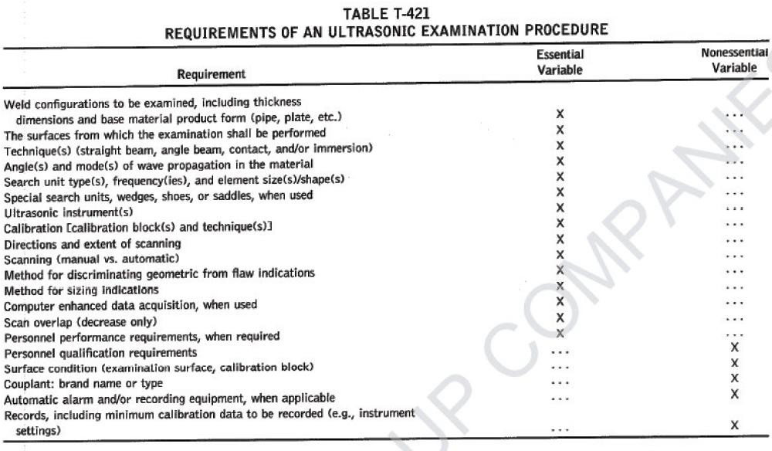

ULTRASONIC TESTING
 | Page 8 of 23 | Rev-0

10.2.3 | Scanning
a) | The probes utilized for scanning of the weld and HAZ shall be the type suitable for the configuration of the piece. The area of interest will be overlapped at least 15% of the probe beam to ensure the full coverage of the area during scanning.
b) | The weld shall be scanned from both sides where possible, with both half and full  skip probe being used.
c) | Great care shall be taken to ensure the transfer value is utilized during scanning to  allow for surface contour. The transfer correction shall be performed for each nominal angle and for each particular new weld being examined.
10.2.4 | Patterns
Patterns for scanning of welds are described in UT Technique Sheets (refer Appendix),brief summary herewith,
Scanning patterns shall be undertaken in at least two directions to locate both longitudinal and transverse discontinuities in the full weld volume and the heat affectedzone (HAZ)
a) | Base metal  Full volume shall be scanned using a normal probe to test for laminar reflectors. Anyloss of back wall reflection or any indication equal to or greater than original reflection shall be recorded.
b) | Longitudinal discontinuities  Movement shall be to and fro normal to weld, length of path sufficient to allow fullskip examination and allowing for 10° swivel in path, paths shall overlap by half ofthe width of the probe to ensure coverage.
c) | Transverse discontinuities  - Ground cap welds shall be scanned using normal and angle probes on weld area.  - Ungrounded welds shall be scanned rotating (weaving) the probe from the axis of the weld by 15° either side producing a zigzag path.
d) | For ESW and EGW welds scanning rotation angle (weave) shall be increased to  45°and 60°

ULTRASONIC TESTING
 | Page 9 of 23 | Rev-0

10.3 | Coverage
 | a) | Butt joints: shall be tested from each side of the weld axis.
 | b) | Corner and T-joint welds: shall be tested from one side of weld axis only.
 | c) | Where due to limitations of access, full scanning cannot be undertaken consideration shall be given to access from opposite side of work piece, failing which alternative methods shall be considered.
10.4 | Defect Location
 | a) | Unacceptable weld areas where discontinuities are found shall be marked clearly on the surface of the piece being examined. A datum point shall be marked which shall generally be the point between two welders, the stop-start area, or the beginning of weld section.
 | b) | The nature, size and depth or discontinuity shall be marked clearly on the parent metal alongside the weld.
11.0 ACCEPTANCE / REJECTION CRITERIA
Unless specified otherwise in writing, acceptance / rejection criteria shall be as that given in AWS Code, Section 6, Part C, and drawing applicable to the part under examination or Phase of ITP applicable, the following shall be applicable:
 | a) | Table 6.2: UT acceptance criteria (Statically loaded non-tubular connections), per  clause 6.13.1
 | b) | Table 6.3: UT acceptance criteria (Cyclically loaded non-tubular connections), per  clause 6.13.2
 | c) | Figure 6.7: Class R - indications, refer clause 6.13.3.1 ( Tubular Connections. UT  Alternative to RT )

ULTRASONIC TESTING
 | Page 10 of 23 | Rev-0

12.0 REPORTING
Ultrasonic examination conducted as per this procedure shall be reported on a standard ultrasonic examination report and shall contain the following information as a minimum and shall be followed para 6.28 and Annex .M From M.11 of AWS D1.1
- Client
- Job number
- Location
- Drawing/line number
- Weld number
- Welder number
- Repair reference
- Flaw detector: type and serial number
- Probe: frequency, size
- Reference block
- Sensitivity
- Couplant
- Scanning area
- Acceptance standards
- Result
- Technician’s name
- Signature & date
- Retest reports shall be identified as R1, R2…, Rn shall prefix the indication number.
13.0 RECORDS
Following acceptance of report by Client, copy shall be filed, together with copies of
sketch(es), specificprocedure(s), photograph(s) or other relevant material, in such manner to
allow easy retrieval if andwhen required.

ULTRASONIC TESTING
 | Page 11 of 23 | Rev-0

14.0 FIGURE 1
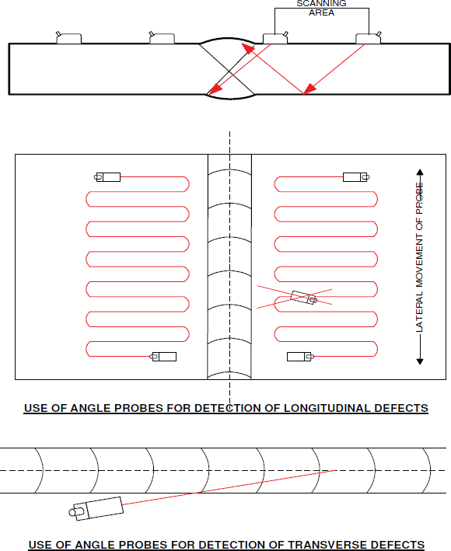

ULTRASONIC TESTING
 | Page 12 of 23 | Rev-0

15.0 FIGURE 2

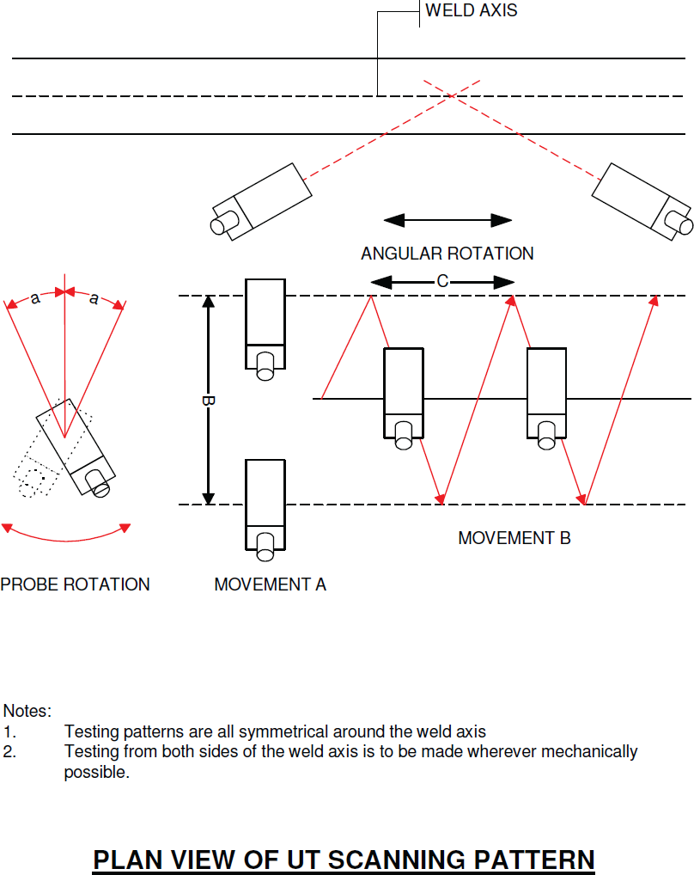

ULTRASONIC TESTING
 | Page 13 of 23 | Rev-0

16.0 FIGURE 3
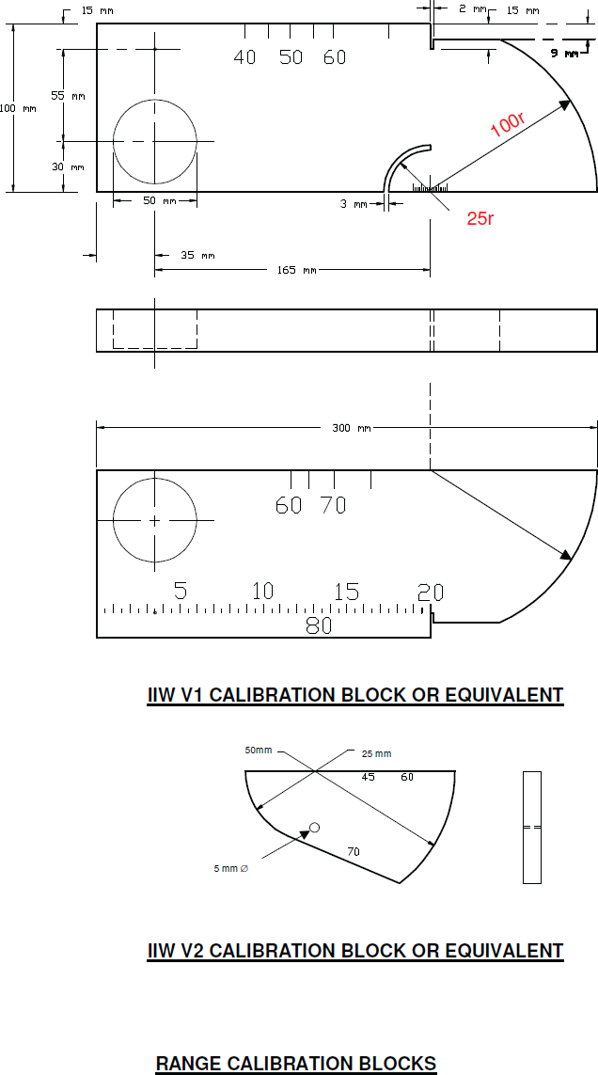
1.6 mm ø

ULTRASONIC TESTING
 | Page 14 of 23 | Rev-0

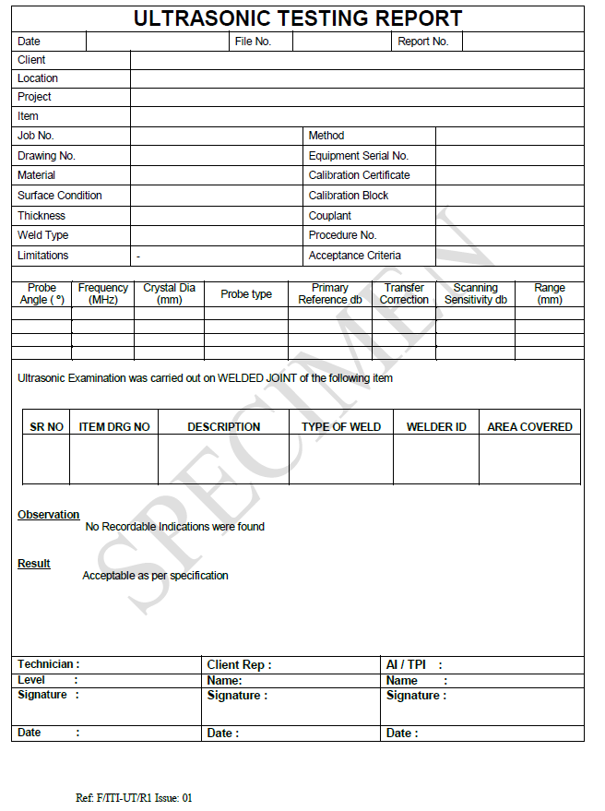
17.0 REPORT FORMAT

dB dB

REMARKS

ULTRASONIC TESTING
 | Page 15 of 23 | Rev-0

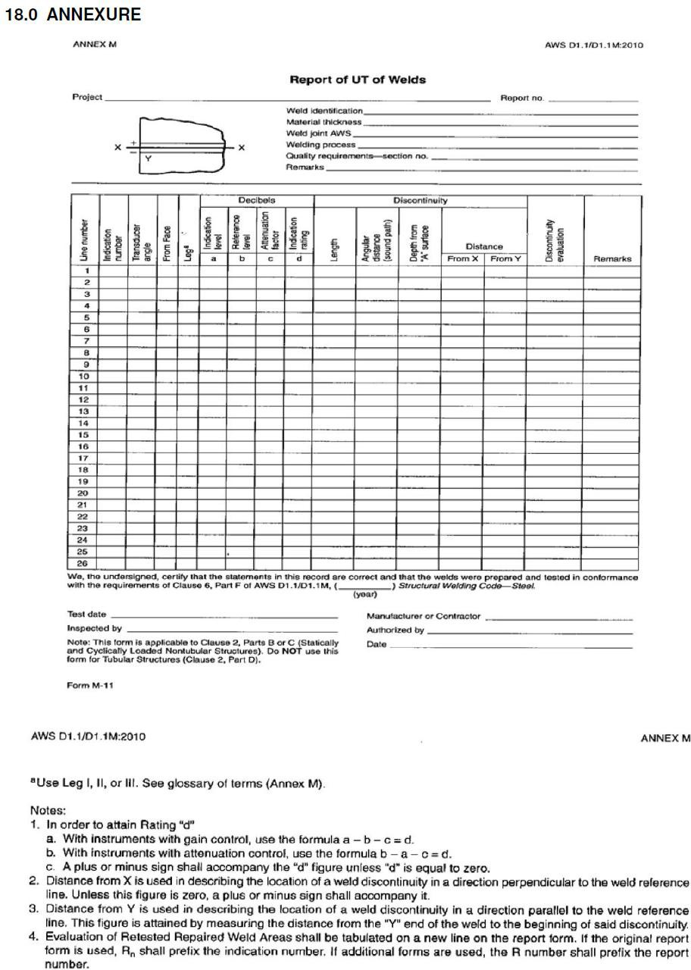
I

ULTRASONIC TESTING
 | Page 16 of 23 | Rev-0

ANNEXURE II
ACCEPTANCE CRITERIA
AWS D1.1 SECT.6 PART C SHALL BE APPLIED
SEE TABLE 6.3 AND TABLE 6.2 BELOW
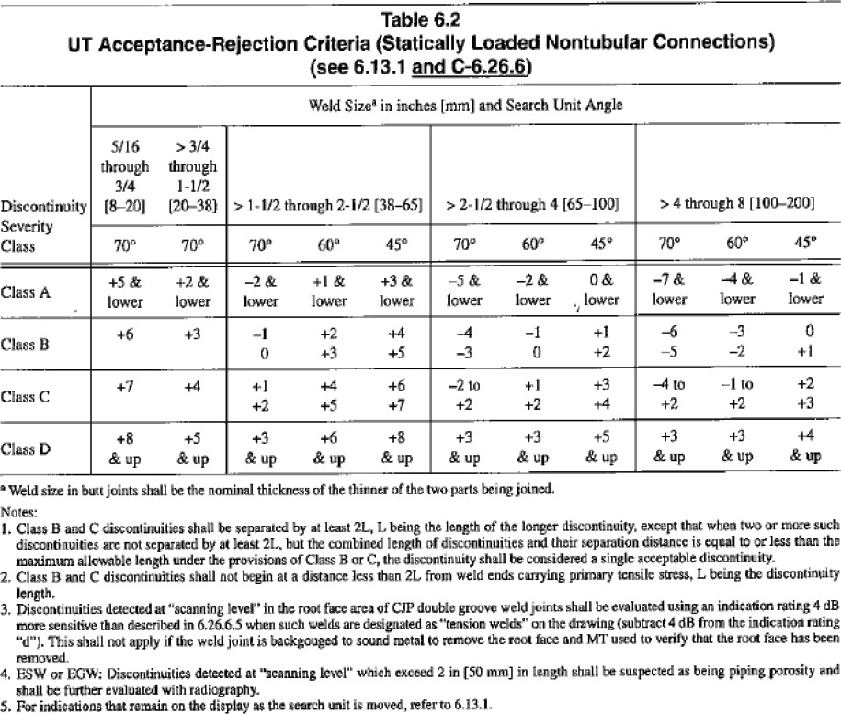
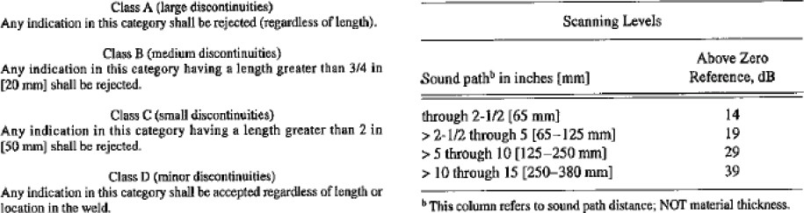

ULTRASONIC TESTING
 | Page 17 of 23 | Rev-0

ANNEXURE III
TABLE 6.2
CLAUSE 6. INSPECTION | AWS D1.1/D1.1M:20210

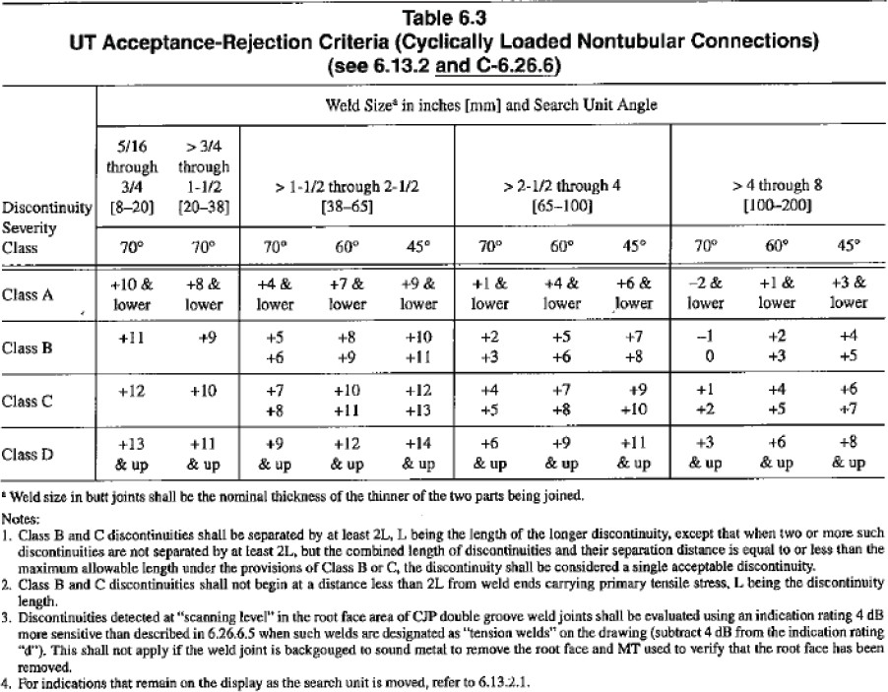
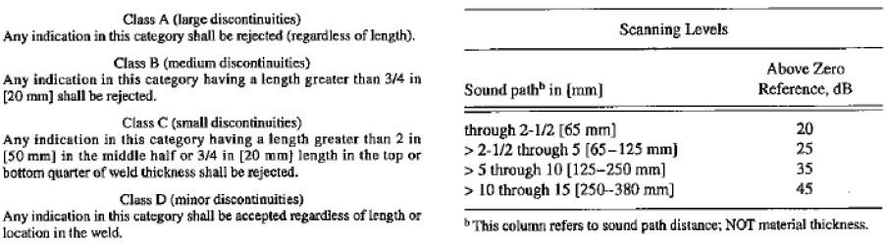

ULTRASONIC TESTING
 | Page 18 of 23 | Rev-0

TECHNIQUE SHEET - 1

Component : But Weld accessible from one side Weld Preparation : Single Vee
Material Thickness: : 8mm and above

PROBE
Angle | Size | Frequency
0° | 10 | 5MHz (TC)
45° | 8 x 9 | 4 MHz (SC)
60° | 8 x 9 | 4 MHz (SC)
70° | 8 x 9 | 4 MHz (SC)
# SC – Single Crystal

TC – Twin Crystal

- 0° probe – Scan till 1 skip distance from weld toe for lamination
- Maintain a fixed root scan at stand-off distance of ½ skip
- Scan the whole volume of weld with appropriate angle probes

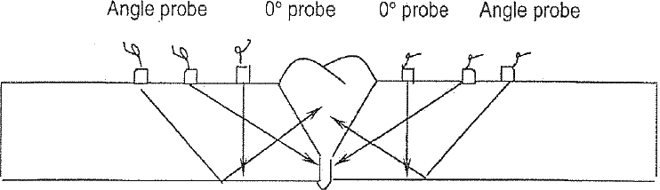

ULTRASONIC TESTING
 | Page 19 of 23 | Rev-0

TECHNIQUE SHEET - 2

Component : But Weld accessible from both side Weld Preparation : Single or Double Vee
Material Thickness: : 8mm and above

PROBE
Angle | Size | Frequency
0° | 10 | 5MHz (TC)
45° | 8 x 9 | 4 MHz (SC)
60° | 8 x 9 | 4 MHz (SC)
70° | 8 x 9 | 4 MHz (SC)
# SC – Single Crystal

TC – Twin Crystal

- 0° probe – Scan till 1 skip distance from weld toe for lamination
- Maintain a fixed root scan at stand-off distance of ½ skip
- Scan the whole volume of weld with appropriate angle probes

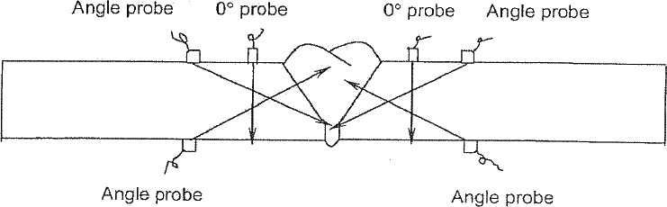

ULTRASONIC TESTING
 | Page 20 of 23 | Rev-0

TECHNIQUE SHEET - 3
Component : Full penetration set-on nozzle
Weld Preparation : Single bevel
Material Thickness: : 8mm and above

PROBE
Angle | Size | Frequency
0° | 10 | 5MHz (TC)
45° | 8 x 9 | 4 MHz (SC)
60° | 8 x 9 | 4 MHz (SC)
70° | 8 x 9 | 4 MHz (SC)
# SC – Single Crystal

TC – Twin Crystal

0° probe – Scan till 1 skip distance from weld toe for lamination
- Maintain a fixed root scan at stand-off distance of ½ skip
- Scan the whole volume of weld on face A with appropriate angle probes

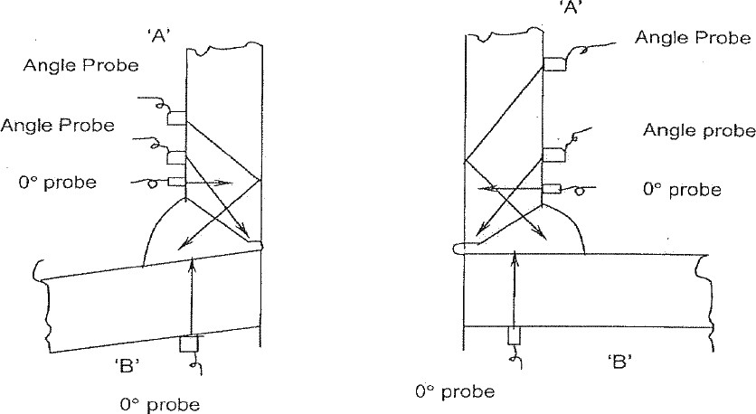

ULTRASONIC TESTING
 | Page 21 of 23 | Rev-0

TECHNIQUE SHEET - 4

Component : Full penetration set-on nozzle Weld Preparation : Double bevel
Material Thickness: : 8mm and above

PROBE
Angle | Size | Frequency
0° | 10 | 5MHz (TC)
45° | 8 x 9 | 4 MHz (SC)
60° | 8 x 9 | 4 MHz (SC)
70° | 8 x 9 | 4 MHz (SC)
# SC – Single Crystal

TC – Twin Crystal
- 0° probe – Scan till 1 skip distance from weld toe on face A for lamination
Scan on nozzle bore face B for imperfections parallel to the nozzle axis e.g. lack of fusion, cracking in nozzle wall and lack of penetration

Maintain a fixed root scan at stand-off distance of ½ skip
- Scan the whole volume of weld on face A and face C with appropriate angle probes

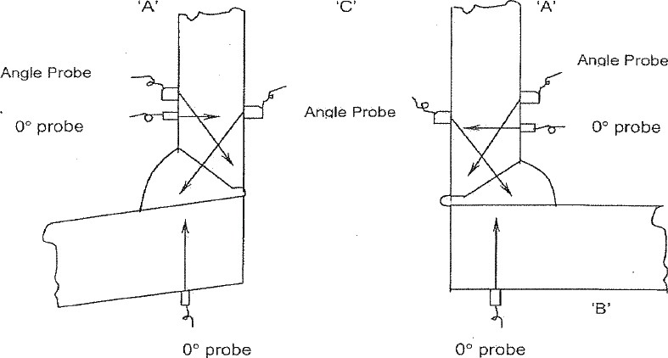

ULTRASONIC TESTING
 | Page 22 of 23 | Rev-0

TECHNIQUE SHEET - 5

Component : Full penetration set-on nozzle Weld Preparation : Single bevel
Material Thickness: : 8mm and above

PROBE
Angle | Size | Frequency
0° | 10 | 5MHz (TC)
45° | 8 x 9 | 4 MHz (SC)
60° | 8 x 9 | 4 MHz (SC)
70° | 8 x 9 | 4 MHz (SC)
# SC – Single Crystal

TC – Twin Crystal

0° probe – Scan till 1 skip distance from weld toe on face A for lamination
- Maintain a fixed root scan at stand-off distance of ½ skip
- Scan the whole volume of weld on face A and face C with appropriate angle probes
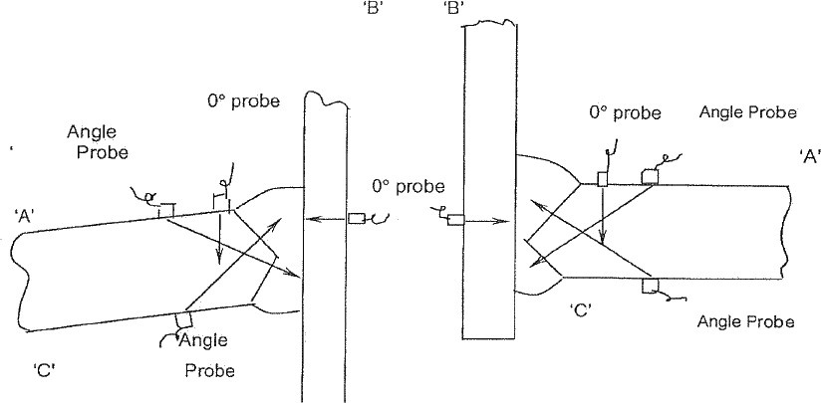

ULTRASONIC TESTING
 | Page 23 of 23 | Rev-0

TECHNIQUE SHEET - 6
Component : T – joint connection Weld Preparation : Double bevel Material Thickness: : 8mm and above

PROBE
Angle | Size | Frequency
0° | 10 | 5MHz (TC)
45° | 8 x 9 | 4 MHz (SC)
60° | 8 x 9 | 4 MHz (SC)
70° | 8 x 9 | 4 MHz (SC)
# SC – Single Crystal

TC – Twin Crystal

0° probe – Scan till 1 skip distance from weld toe on face A for lamination Scan on tube plate face C for lack of fusion, cracking, tearing etc
- Maintain a fixed root scan at stand-off distance of ½ skip
- Scan the whole volume of weld on face A and face B with appropriate angle probes

