
Welding Inspection

Terms & Definitions

Terminology and Definitions

A Weld:
A union between materials caused by heat, and or pressure

A Joint:
A configuration of members

Terminology Joint Welds
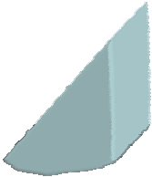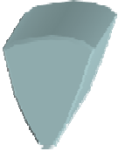
Compound Fillet Butt

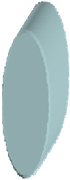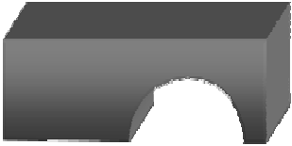
Edge Spot Plug

Terminology Joint Types


Edge Open & Closed Corner Lap



Tee

Cruciform
Butt

Included angle
Included angle

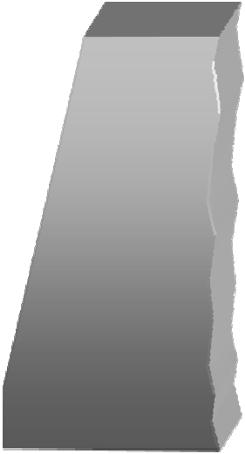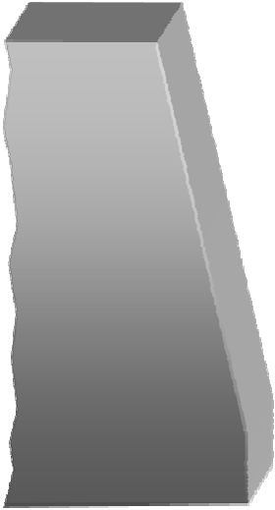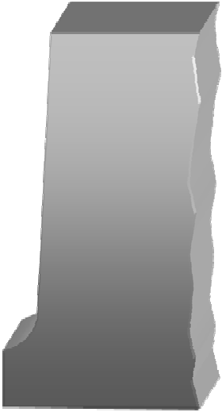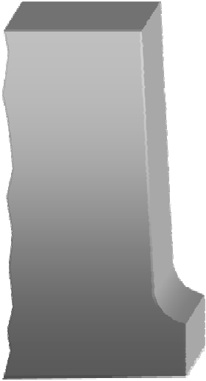Angle of bevel

Root Radius

Root Gap
Root Face

Root Gap
Root Face

Single - V Butt Single - U Butt

Angle of bevel
Angle of bevel

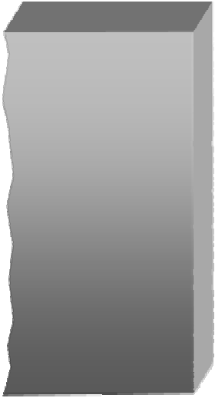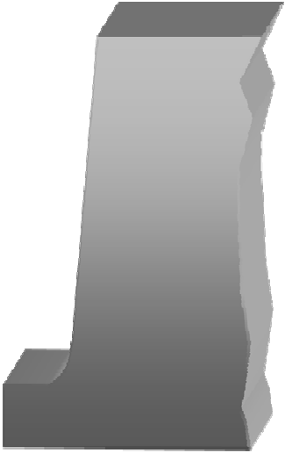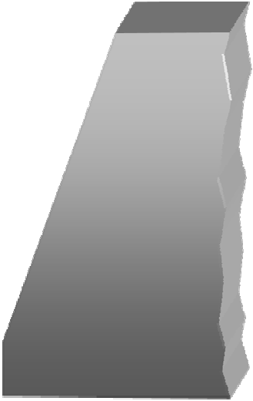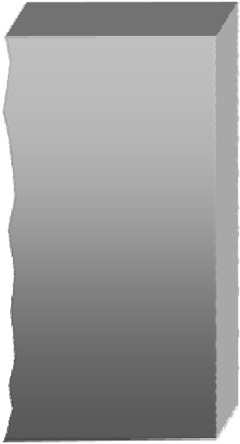Root Face
Root
Radius
Root Gap
Root Face
Land
Root Gap

Single Bevel Butt Single J Butt

Single Butt Weld Preparations
Single sided preparations are normally made on thinner materials, or when access form both sides is restricted

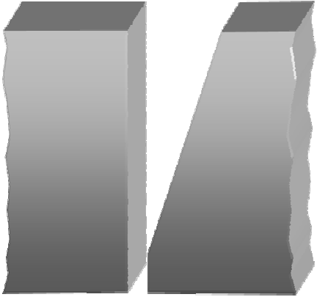
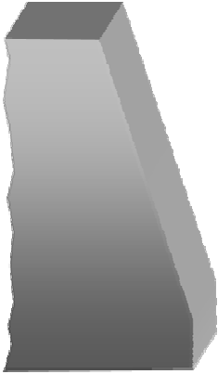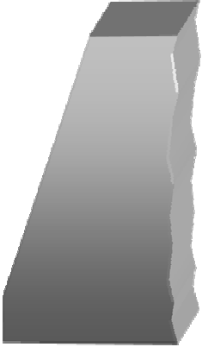

Single Bevel
Single
Vee

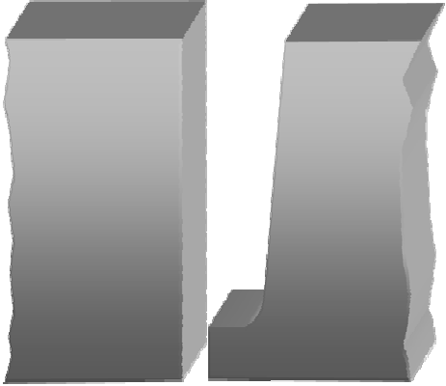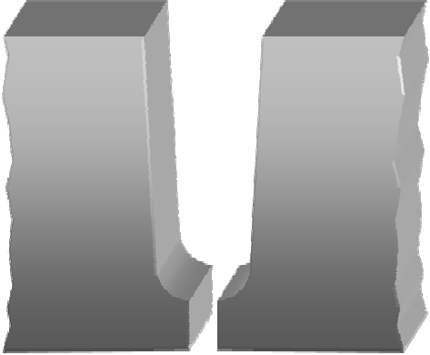

Single J Single U

Double Butt Weld Preparations
Double sided preparations are normally made on thicker materials, or when access form both sides is unrestricted

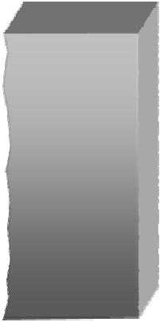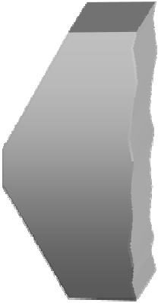

Double
Bevel
Double
Vee

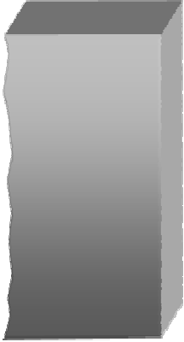
Double J Double U

Welded Butt Joints

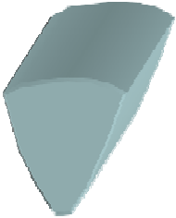A Butt Welded butt joint

A Fillet Welded butt joint

ACompound Welded butt joint


Welded Tee Joints

A Fillet Welded T joint

A Butt Welded T joint

ACompound Welded T joint


Welded Lap Joints

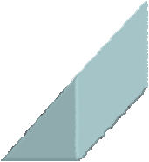A Fillet Welded lap joint

A Spot Welded lap joint

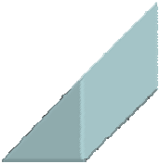ACompound Welded lap joint

Welded Closed Corner Joints

A Fillet Welded closed corner joint

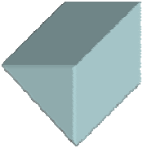A Butt Welded closed corner joint

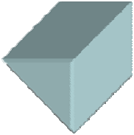ACompound Welded closed corner joint

Welded Open Corner Joints

A Inside fillet
Welded open corner joint

A Outside fillet Welded open corner joint

A Double fillet
Welded open corner joint

Weld Zone Terminology

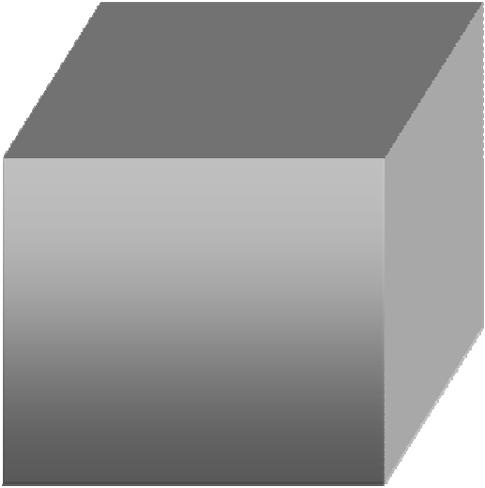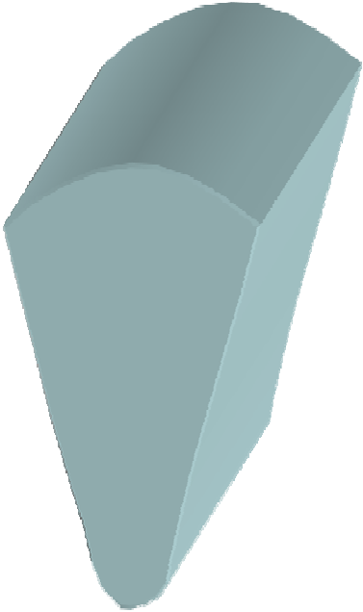Weld Toe
Weld zone
Weld metal

Heat affected zone

Fusion zone

Weld Toe
Root
Weld Junction

Weld cap width
Excess cap height
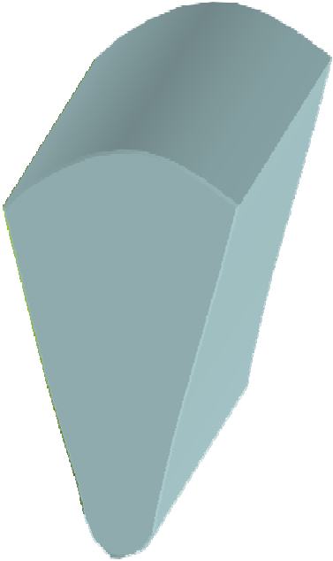or weld reinforcement

Excess root penetration

Root bead width

Actual throat
Design throat
Cap or Face Cap width

A 1 2

B 3 4
1,2,3,4 = Weld toes

Weld Junction

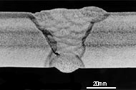HAZ Root
A & B = Excess weld metal

Fusion zone

Fillet Weld Features
Vertical leg length
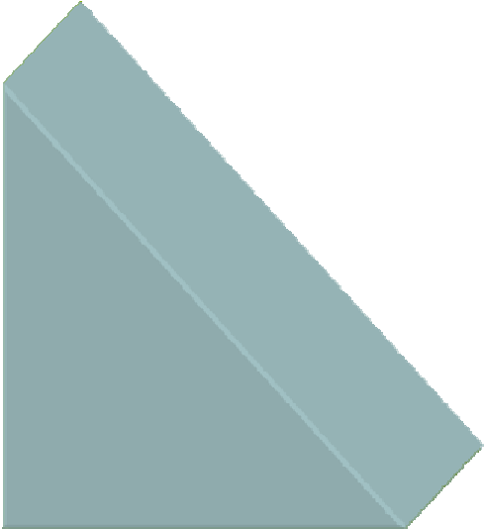

Nominal design throat thickness

Horizontal leg length

Fillet Weld Dimensions

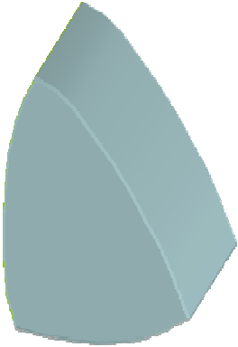a = Nominal design throat thickness
s = Actual throat thickness
c b = Horizontal leg length c = Vertical leg length
e.g
Leg length = 6mm
a Design Throat = 6mm x 0.7
b s Design Throat = 4.2mm

The leg length should be approximately equal to the material thickness
The design throat thickness is 0.7 of the leg length

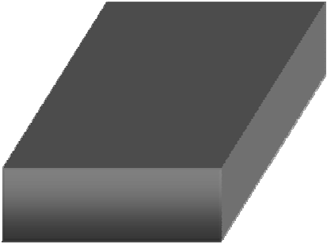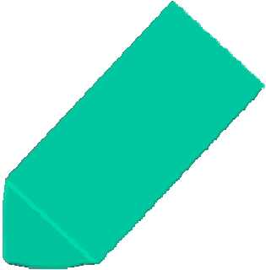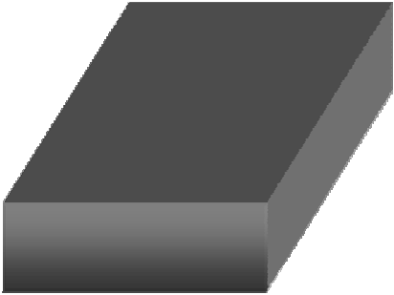Fillet Weld Profiles

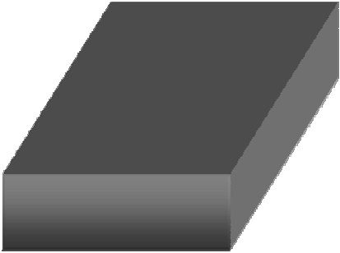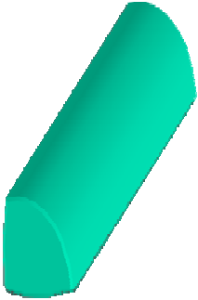
Mitre fillet Convex fillet

Concave fillet
A concave profile is preferred for joints subjected to fatigue loading


Toe Blend Angle

Poor Weld Toe Blend Angle

Improved Weld Toe Blend Angle
- Most codes quote the weld toes shall blend smoothly
- 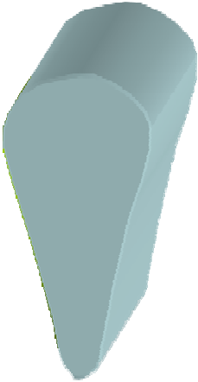This statement is not quantitative and therefore open to individual interpretation
6 mm
80°
- 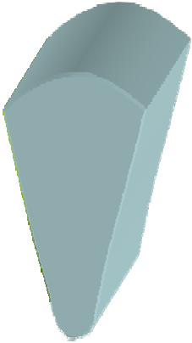The higher the toe blend angle the greater the amount of stress concentration
3 mm
20°
- The toe blend angle should be between 20o-30o

Flat: PA / 1G:
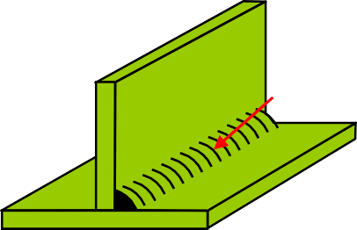
Horizontal vertical: PB / 2F:

Flat PA / 1F

Horizontal vertical:

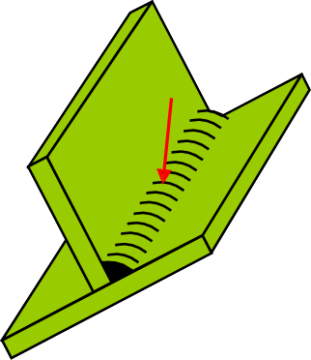
Vertical upwards PF / 3G

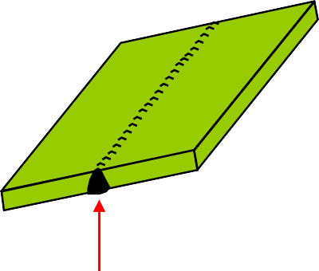
PC / 2G:
Overhead
PE / 4G
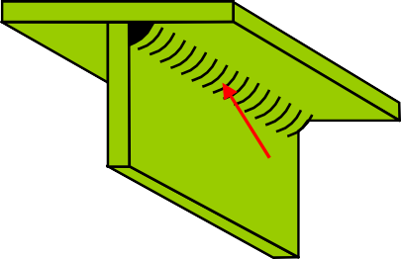
Horizontal overhead PD / 4F
Vertical downwards PG / 3G

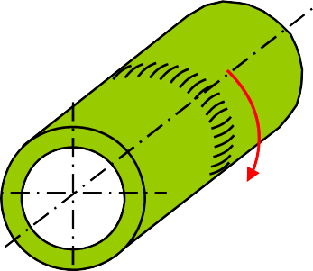

PG / 5G

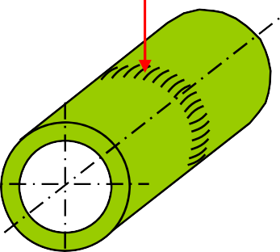Weld: Flat Pipe: rotated

PA / 1G
Axis: Horizontal
Weld: Vertical upwards Pipe: Fixed
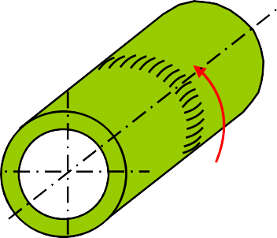Axis: Horizontal

PF / 5G
Weld: Vertical Downwards Pipe: Fixed
Axis: Horizontal
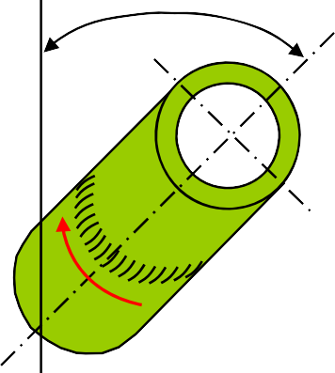
45o

PC / 2G
Weld: Horizontal vertical Pipe: Fixed
Axis: Vertical
H-LO 45 / 6G
Weld: Upwards Pipe: Fixed Axis: Inclined

Any Questions


Questions

QU 1. Sketch a single-U butt joint and indicate the following
a. Root face b.Root gap c.Included angle d. Root radius

QU 2. Sketch a tee joint, fillet welded and indicate the following
a. Leg length b.Throat thickness c. Root d. Weld toes QU 3. Sketch five joint types in addition to a butt joint
QU 4. Identify the the following features from the sketch
F
E
D C
B
A

Welding Inspection

Welding Symbols


BS 499 part 2 Welding Symbols




Welding Symbols
Weld symbols are used to transfer information from the design office to the workshop and contain five basic components
- The arrow line: the arrow line must touch the joint reference area on the drawing
- The reference line: the reference line must touch the arrow line and is generally parallel with the bottom of the drawing page
- The symbol: the vertical line in the symbols for a fillet weld, single/double bevel butts and a J-butt welds must always be on the left side.
- The dimensions: In most standards the cross sectional dimensions are given to the left side, and all linear dimensions are give on the right side
- Supplementary information: such as welding process, weld profile, NDT and any special instructions

Other side

Reference line
Arrow side
Arrow line

Other side Arrow side Both sides

a b

c d

BS 499: part 2. Welding Symbols

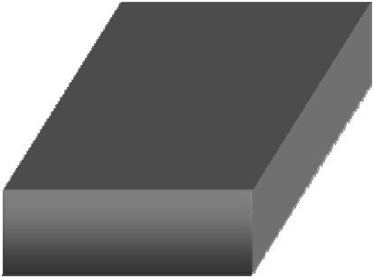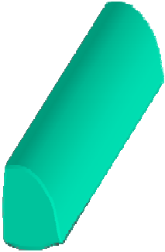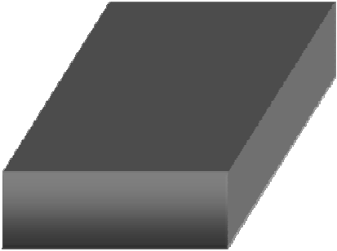
Flat
Convex

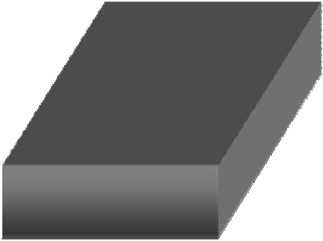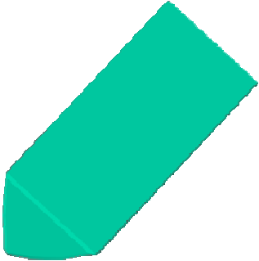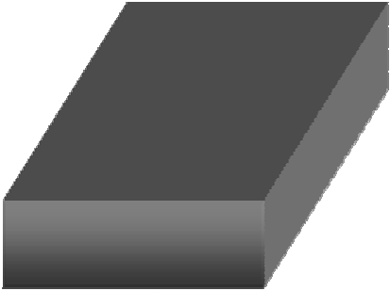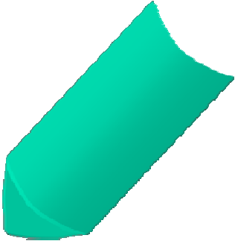
Concave
Toes
shall be blended

Welding to be carried out all round component (peripheral weld)

Field weld (site weld)

WPS
NDT
The component requires

NDT inspection
Additional information, the reference document is
included in the box

Peripheral Welds
10
8

10
8
8

10

a = Design throat thickness s = Actual throat thickness b = Leg length
(min material thickness) a = 0.7 of b

a 4
b a s 4mm Design Throat

b 6 s 5

6mm Leg
5mm Actual Throat

5
8
8
5

5

OR

All dimensions in mm
8
5

n = number of weld elements
n x l
(e)
l = length of each weld element
(e) = distance between each weld element

3 x 40 (50)
2 x 40 (50)
Welds to be staggered

111

Process

All dimensions in mm
8 3 x 80 (90)
6 3 x 80 (90)

80 80 80
6
6

8
8

90 90 90

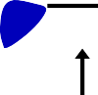
6
6
5
5
5
6
3 x 80 (90)
3 x 80 (90)
80
80
80
90
90
90

Single-V Butt Single-U Butt

Single-V Butt flush cap Single-U Butt with sealing run

Single-bevel butt Double-bevel butt

Single-bevel butt Single-J butt

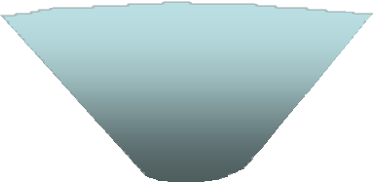
10
10
15

Partial penetration single-V butt

Plug weld

Square Butt weld

Single-V Butt broad root face

Spot weld

Seam weld

Edge flange weld

BS 499: part 2. Flared flange Welding Symbols

Joint detail

Joint detail

BS 499: part 2. Numerical Indication of Process

111: MMA welding with covered electrode 121: Sub-arc welding with wire electrode 131: MIG welding with inert gas shield
135: MAG welding with non-inert gas shield 136: Flux core arc welding
141: TIG welding
311: Oxy-acetylene welding
72: Electro-slag welding

7
10

35 20
15 30

All fillet weld leg lengths 10 mm

131 / 111

7 10
35

15
b10 a 7
35
b10
30
20
b10

20
30

131 / 111

15
b10
All fillet weld leg lengths 10 mm

- Welded both sides: A continuous concave fillet weld 6mm leg lengths.
BS 499: prt. 2 Fillet Welds ex: 1
6
6
12
6
2 x 30
3 x 20
(10)
(30)

- Welded arrow side: Three intermittent fillet welds, 6 mm leg lengths, the length of each weld
20 mm, the distance between each weld 30 mm. ²⁰ ³⁰ ²⁰
Welded other side: Two intermittent fillet welds 12 mm leg lengths, the length of each weld 30 mm, the distance between each weld 10 mm.
30 20

Welds to be staggered. ¹⁰
- Welded both sides. A continuous fillet weld, 6 mm leg lengths, 4 mm throat thickness, welds to be carried out on site.
- Welded arrow side: Three intermittent fillet welds 10 mm leg lengths, 7mm throat thickness, length of each weld 15 mm, the distance between
30 10 30 10
(b) 6 (a) 4
(b) 6 (a) 4

(b)15 (a)10.5
(b)10 (a)7 3 x 15 (25)

each weld 25 mm.
Welded other side: A continuous convex fillet weld, 15 mm leg length, 10.5 mm throat thickness.
15 25
15 25 15


BS EN 22553 (ISO 2553)
Welding Symbols

Reference lines
Arrow line

Other side Arrow side
Arrow side
Other side

Other side

Both sides

Arrow side

a
b
c
d

BS EN 22553 (ISO 2553) Welding Symbols

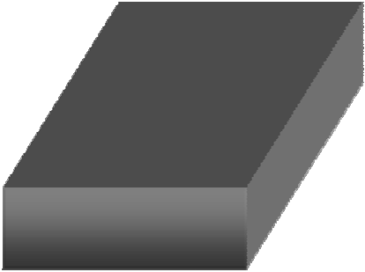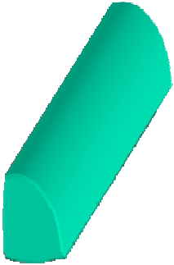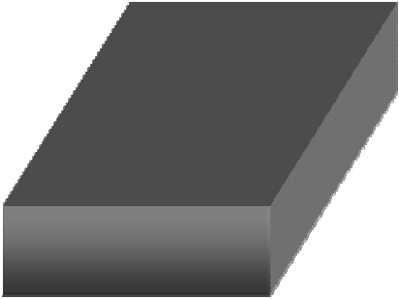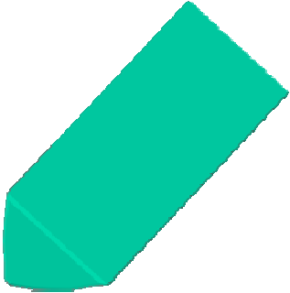
Flat
Convex

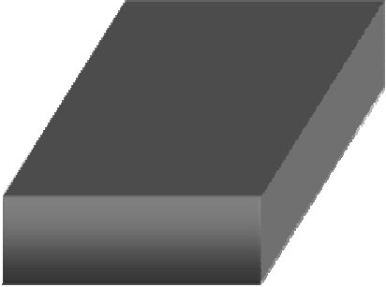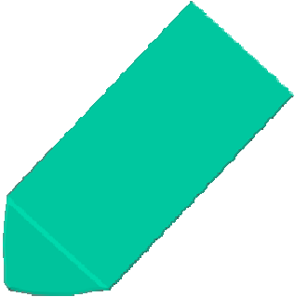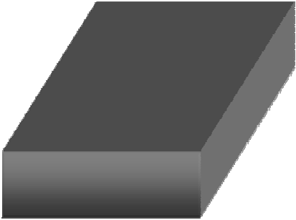
Concave
Toes
shall be blended

Welding to be carried out all round component (peripheral weld)

Field weld (site weld)

WPS
NDT
The component requires

NDT inspection
Additional information, the reference document is
included in the box

Peripheral Welds
z10
z8

10
8
8

10

a = Design throat thickness s = Actual throat thickness z = Leg length
(min material thickness) a = 0.7 of z

a 4
a 4mm Design throat

z s
z 6 s 5

6mm leg
5mm Actual throat

n = number of weld elements
n x l
(e)
l = length of each weld element
(e) = distance between each weld element

Welds to be staggered
 |  | 2 x | 40 |  | (50)
 |  | 3 x | 40 |  | (50)

111
Process

All dimensions in mm
z8 3 x 80 (90)

z6 3 x 80 (90)

80 80 80
6
6

8
8

90 90 90

z5 3 x 80 (90)
6
6
5
5
z6
3 x 80 (90)
80
80
80
90
90
90

M R

M

Single-V Butt with permanent
backing strip
Single-U Butt with removable backing strip

Single-V Butt flush cap Single-U Butt with sealing run

Single-bevel butt Double-bevel butt

Single-bevel butt Single-J butt

10
10

Partial penetration single-V butt

Plug weld

Square Butt weld

Steep flanked Single-V Butt

Spot weld

Seam weld

Surfacing

BS EN 22553. Flared flange Welding Symbols

Joint detail

Joint detail

BS EN 22553. Numerical Indication of Process

111: MMA welding with covered electrode 121: Sub-arc welding with wire electrode 131: MIG welding with inert gas shield
135: MAG welding with non-inert gas shield 136: Flux core arc welding
141: TIG welding
311: Oxy-acetylene welding
72: Electro-slag welding

7
10

35 20
15 30

All fillet weld leg lengths 10 mm

7 10
35

15
z10 a 7
35
z10

30
20
z10

20
30

131 / 111

131 / 111

15
z10
All fillet weld leg lengths 10 mm

BS EN 22553 Fillet Welds ex: 1
- Welded arrow side: A continuous fillet weld with a 6 mm leg length , toes to be blended smoothly.
6
6
6
3 x 25 (40)
3 x 25 (40)

- Welded both sides: Three intermittent fillet welds with 6 mm leg lengths, the length of each
weld 25 mm and the distance between each ²⁵
weld 40 mm.
- Welded arrow sides: Three intermittent fillet
40 25 40 25

welds with 10 mm leg lengths, the length of each weld 40 mm, the distance between each weld 30mm.
40
30
40
30
10
6
40
3 x 40
3 x 50
(30)
(25)
30
Welded other side: Three intermittent fillet welds 6 mm leg lengths, the length of each weld 50mm and the distance between each weld 25mm, welds to be staggered.
25 40 25
40 25

- Welded arrow side: Three intermittent fillet welds with 8 mm leg lengths, the length of each weld 25 mm and the distance between each weld 50 mm.
Welded other side: Two intermittent fillet welds with 10 mm leg lengths, the length of each weld 20 mm and the distance between each weld
50 25

25 50
50 25

25 50
50
8 3 x 25 (50)
10 2 x 20 (40)

25

40mm, welds to be staggered.
40 20 40 20


M
Ans to BS EN 22553 Butt Welds ex: 1

  - Welded arrow side: Single-V butt weld with permanent backing strip, flat weld profile.
  - Welded other side: Single-U butt weld, flat weld profile

  - Welded arrow side: Single-V butt weld depth of preparation 10 mm
10
Welded other side: Backing run. (Plate thickness 15 mm.)
12
12
8

  - Welded arrow side: Single-J butt weld, depth of preparation 12 mm with a 8 mm fillet weld superimposed. (plate thickness 15 mm.
Welded other side: 12 mm leg length fillet weld.


AWS Welding Symbols



Depth of Bevel

1(1-1/8)

1/8 60o
Root Opening

Effective Throat
Groove Angle

Welding Process

FCAW
1(1-1/8)
1/8
60o

GMAW GTAW SAW

Applicable to any single groove weld

1(1-1/8)

Single Bevel
FCAW

Welds to be staggered

3 – 10
3 – 10

SMAW

Process

10
3
3

Sequence of Operations
3rd Operation 2nd Operation

1st Operation

FCAW

1(1-1/8)
1/8 60o

Sequence of Operations

1(1-1/8)

1/8 60o
RT

MT MT
FCAW

Dimensions- Leg Length

6 leg on member A
6/8

Member A

=
6
8

Member B

